Tips on how to listen to music
These notes have been adapted from Playlist for Life’s online suggestions: http://www.playlistforlife.org.uk/how-to/use-the-technology/
Once the playlist is drawn up, what then?
It doesn’t matter if a person with dementia is unlikely to switch on an iPod themselves – the point is that there is someone at hand to do it for them, and with them, as often as possible.
We’d encourage carers/family members to introduce the playlist as often as possible and use it as an opportunity for closeness and to conversation. Of course someone enjoying their playlist can be left to listen in peace, but this is an intervention that both encourages and demands social engagement.
Using it at Home
At home you may find that what works best is a routine of offering the playlist at particular times of day, with more get-up-and-go music chosen on some occasions and calmer pieces at other times.
Or it can be offered in response to agitation, boredom or feeling low – or indeed in anticipation of these. Getting in first with the music when you know a particular activity is likely to prove difficult is often helpful.
Try it out and see what works best. Identifying critical periods for offering this intervention is a focal point of ongoing research.
Remember the iPod can stay with your relative – added to and refreshed as more pieces occur to you – the whole length of their dementia journey. Wherever they go, their playlist for life is an introduction to the person they really are.

How long should this music be offered at a time?
Structuring the listening to occur 15 minutes at a time throughout the day has been shown to increase the beneficial effect.
Alternatively an hour or so would be a good session of passive listening.
However, remember that if music is left on all the time, people are only occasionally engaged and it can just become noise.
Ultimately it’s whatever you can manage, as often as works best for you and your loved one.

Headphones
Headphones can help a listener to fix their attention on their own playlist when they are in a public room surrounded by other people and competing sounds – or simply when they have difficulty in concentrating.
We have provided you with ear bud type headphones. Not everyone is comfortable with these. They might fall out! If so, perhaps you should use a set of headphones that go over the ears and are lightweight and comfortable. Maybe you have a pair lying about, or you can buy them from the High Street.
Listening together
Key to the experience of sharing a playlist with a loved one who has dementia is that, as far as possible, you should be able to listen and enjoy together.
A headphone splitter cable enables you to listen to the playlist with another person at the same time. This costs under £10
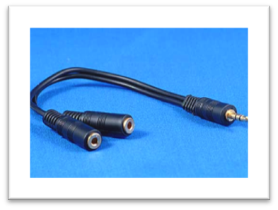

OR you can put the device in a docking station. You can also buy cheaper speaker systems and there is also a wireless option. You may find it helpful to have both, for listening in different settings.

Battery
Whichever mp3 player you use, remember to charge the battery regularly after use or it won’t work.

I see the value, but this digital thing is beyond me.
Use any youngster within reach to help you! What about grandchildren, neighbours or friend’s children? This is a way of involving the younger generation who lives and breathes computers with the generation who mostly missed it.
Playlist for Life have also produced a Use the Technology guide to help you (http://www.playlistforlife.org.uk/how-to/use-the-technology/)\

Is there a downside?
Using music intensively to affect emotions and memory is a delicate matter. There are no rules. In every instance this is about responding lovingly to a unique individual and taking our cue from them. Music is powerful.

What can the music do?
- Improve wellbeing
- Help people become more lucid and find it easier to think
- Help people be ‘more themselves’
- Help with agitation, makes people feel safe
- It may help bring back words and keeps you mentally engaged
- It may help form new memories
- It might bring tears – but it may be right to carry on as tears can be cathartic.

YOUR CHALLENGE

Try it out and see what the music can do for you?

Think about….
- How and when have you used it?
- How has it made you feel as an individual?
- What this has meant for you as a couple/family?
- What worked best for you?
- What didn’t work for you?
- Anything else?

