Keeping it Personal | 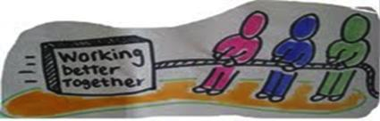

Do you have a diagnosis of dementia or are you a carer of someone with dementia?

Would you like to be part of a group helping to make sure that people with dementia and their carers in North West Glasgow get the right support?

What will it involve?

You would meet with a group of other people, some with lived experience of dementia and others from Health Services, Social Work, and other organisations like Alzheimer Scotland.

All group members would have an equal say. The group would value your knowledge and expertise as a person living with dementia or caring for someone with dementia in North West Glasgow

You would be asked to attend six sessions (10am-3.30pm) with a little homework in between. The aim would be to find ways to make life better for people with dementia and carers in North West Glasgow.

- Wed 12 February 2014 | - Wed 13 August 2014
- Wed 2nd April 2014 | - Wed 8 October 2014
- Wed 11 June 2014 | - Date in Dec 2014- to be confirmed

All meetings at: Whiteinch Community Centre, 1 Northinch St, Glasgow, G14 0UG

More about the meetings

At the meetings there will be small group discussions, with someone making sure that everyone is treated with dignity and respect. They will make sure you have any support you need to contribute.

Lunch, tea and coffee will be provided, with regular breaks to keep things relaxed.

All travel and parking costs will be paid for and you will be paid £100 for attending each session in recognition of your contribution.

How to get involved?

If you are interested in taking part or would like to hear more before you decide, please call Kerry Musselbrook for an informal chat: 0141 559 5062 (kerrymusselbrook@iriss.org.uk).

